Take the "I Recycle" Pledge Online- Win $300
Monday, 18 Oct 2021

Public Works / Solid Waste Management

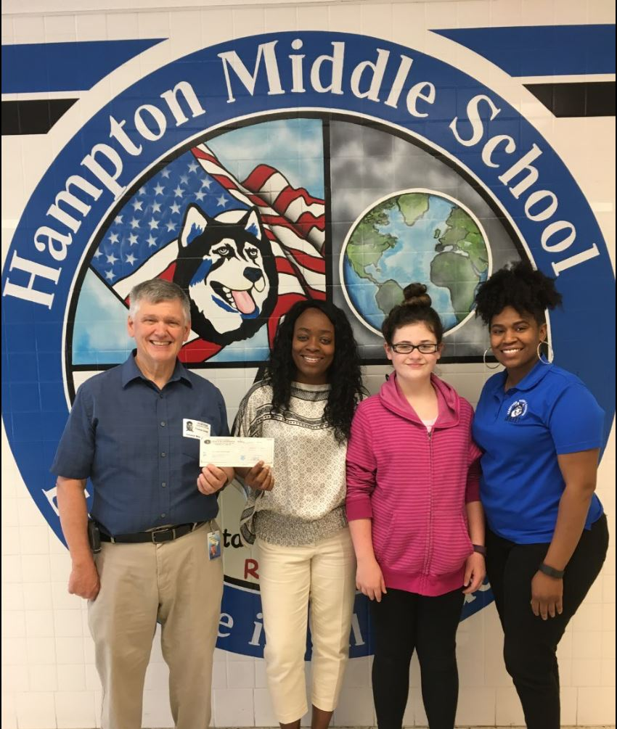
America Recycles Day Recognition 2021
Solid Waste promotes “I Recycle” Pledge

America Recycles Day takes place annually on November 15. Prince William County will join thousands of local organizers and Metropolitan Washington Council of Government (MWCOG) jurisdictions to celebrate America Recycles Day (ARD), a national initiative of Keep America Beautiful.
Prince William County residents can acknowledge their commitment to recycling and win prizes by taking the “I Recycle” pledge. The contest, hosted by MWCOG, will accept pledges online until November 20. One lucky recycling supporter will win a $300 REI gift certificate and one lucky K-12 student will win a $300 REI gift certificate and a $500 grant for a recycling or environmental program at their school or in the Prince William community. For eight of the past nine years, a Prince William entrant has won a MWCOG regional prize.
Prince William area residents may take the 2021 “I Recycle” Washington area pledge online at www.mwcog.org/recyclesday before November 20 and be entered in the MWCOG drawing.
For more information about recycling in Prince William County, visit www.pwcva.gov/recycling. For more information about Keep America Beautiful and America Recycles Day visit https://kab.org/programs/ard/.

