POSSUM POINT POWER STATION COAL ASH UPDATE
Monday, 1 Jun 2020

Public Works / Solid Waste Management

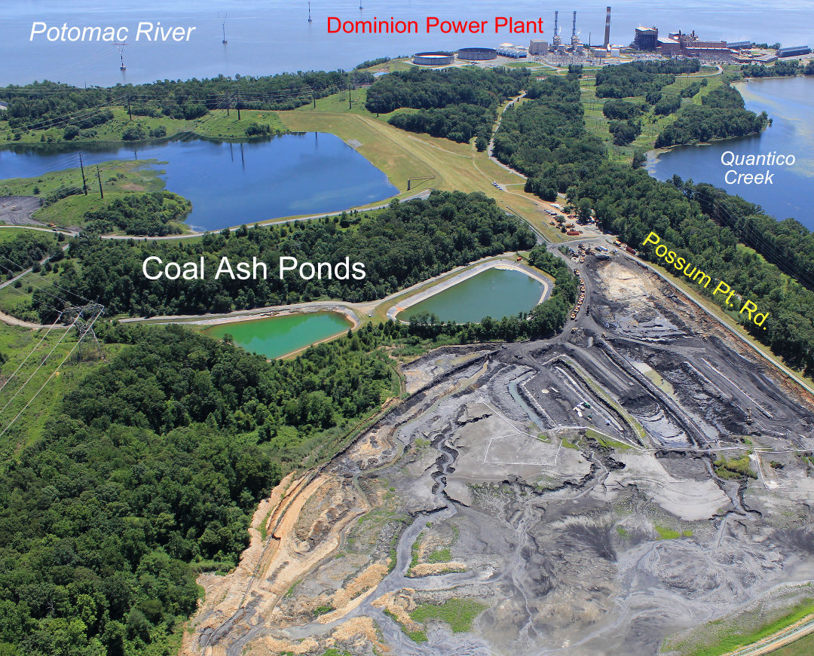
Prince William County staff, in coordination with Potomac District Supervisor Andrea Bailey and Board Chair Ann Wheeler, have been monitoring the management and closure of the coal ash ponds by Dominion Energy Virginia (Dominion) at the Possum Point Power Station (Possum Point) located in eastern Prince William County.
There are five coal ash ponds located on the site, designated as Ponds A, B, C, D and E. Dominion has received a closure permit from the Virginia Department of Environmental Quality (VDEQ) to remove all of coal ash from Pond A, B, C and E, regrade the pond areas and permanently close these ponds. All the coal ash from Ponds A, B, C and E has been removed and placed into the Pond D. Dominion is in the process of obtaining final approval from the county staff for a grading plan for Ponds A, B, C and E, and once certified by a professional engineer that all ash has been removed from these ponds, these ponds will be regraded for positive drainage and seeded. County staff are monitoring this process to “clean close” these ponds, including review of annual groundwater monitoring reports, to ensure all VDEQ permit requirements are met.
Pond D has approximately four (4) million cubic yards of coal ash remaining. In accordance with the Virginia Acts of Assembly – 2019 Session, Chapter 650, Dominion must complete closure of Pond D by removing all of the coal ash in the following manner : • Beneficially reusing some or all of the coal ash through a recycling process located on or off-site, and/or • Disposing of some or all of the coal ash in a new, modern and fully permitted landfill, which includes a composite liner and is located on or off-site.
Dominion is required to beneficially reuse a portion of the coal ash at two of its four sites in Virginia, which may include Possum Point. Dominion is also required to develop a transportation plan in consultation with the county for the removal of any coal ash or recycling coal ash products that are removed off-site. The county has informed Dominion of its opposition to trucking coal ash from this site due to the number of trucks and the impact of truck traffic on the existing road network. The county has advised Dominion to consider removing any coal ash by rail and/or barge. Under the current state legislation, once the closure process has been initiated at Possum Point, Dominion will have 15 years to complete the process.
Dominion must obtain a state solid waste permit from VDEQ before closing Pond D. As part of the solid waste permit application process, the Board and members of the public will have an opportunity to comment on the application and draft permit. When Dominion files its solid waste permit application, county staff will review the application and VDEQ draft permit and provide staff’s recommendations to the Board for its consideration.
Prior to removal of the coal ash from Pond D, Dominion is required to remove and treat all the water in Pond D. This water must be treated in accordance with the conditions of the state water discharge permit granted by VDEQ in 2016, along with the additional, more-stringent water treatment requirements negotiated by the Board per its agreement with Dominion. Once treated, the water will be discharged into Quantico Creek. The process to treat this water is now on hold and will restart as part of the process to close Pond D, and remove and dispose of the coal ash.
Dominion is currently evaluating all options to remove the coal ash from, dispose of the coal ash and close Pond D. They have issued a request for proposal from private businesses to consider options for the beneficial reuse and recycling of some or all of the coal ash at Possum Point. Dominion has received responses to this proposal in which are currently under review. County staff has been advised by Dominion that this review, along with review of all options to remove the coal ash from Pond D, will not be completed until the fall of 2020. County staff will continue to engage with Dominion and VDEQ during the closure process on behalf of the Board to ensure the health and safety of the community and natural environment.
Dominion has also begun a process to test private wells and public water supply wells located within 1.5 miles of a coal ash pond as required by the Virginia Acts of Assembly, 2020 Session, Chapter 845. Dominion is in the process of performing a survey of the affected properties and these property owners will be notified by Dominion in accordance with Virginia Acts of Assembly – 2020 Session, Chapter 625.
Some of the coal ash ponds at Possum Point date back to at least the 1950s, while others were constructed in 1967 and 1988. In 1986, the county’s Zoning Administrator at that time determined that the proposed use of the Possum Point Power station to build a fly ash disposal pond is a continuation of an existing use, is permitted by right as a public use, and a public facilities review is not required. Once Dominion provides details to the county on its plan for removal, recycling, disposal and/or landfilling of the coal ash, the county will make a determination as to what additional county approvals are required.
If any resident or property owner has any questions on the status of the coal ash project at the Possum Point Power Station, please contact the county’s Department of Public Works, Solid Waste Division at (703) 792-4670, or send an email to CoalAsh@pwcgov.org.

