**New Yard Waste Collection Program**

Monday, 18 Oct 2021

[Solid Waste Management](https://www.pwcva.gov/department/solid-waste-management)

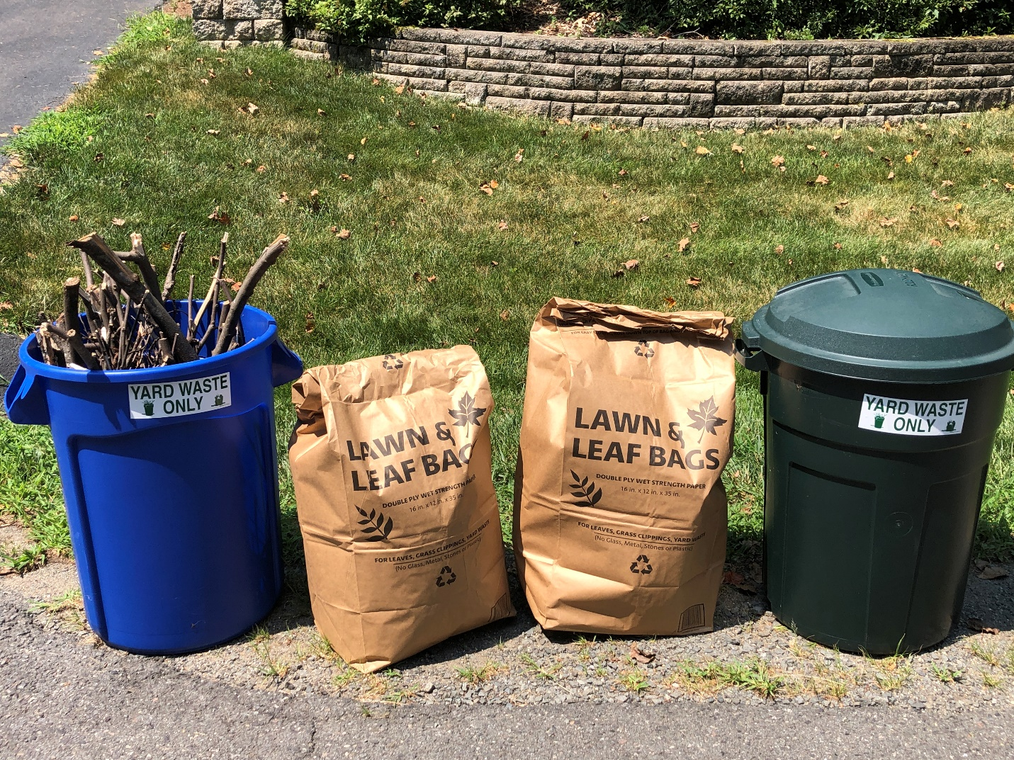

**New Yard Waste Collection Program**

*No plastic bags*

On Dec. 15, 2020, the Prince William Board of County Supervisors unanimously approved changes to Chapter 22 (Refuse) of the County Code.  As a result of this code change, a new curbside yard waste collection program  began on Oct. 1.  Like trash and recycling, yard waste will be collected weekly by trash and recycling collection companies.  Yard waste must be placed in biodegradable paper bags or containers labeled “Yard Waste” to be picked up.  Labels are available at the County Landfill or Balls Ford Road Compost Facility.  Plastic bags should no longer be used for yard waste collection.

Residents, businesses, apartments, landscapers, etc. are all required to arrange for a separate collection of yard waste, leaves and brush. The yard waste collection program is seasonal and will run March through December, each year. In addition to yard waste collection, Christmas trees will be collected during the first two weeks of January. Residents and business may contact their trash and recycling hauler for information on yard waste collection days, provision of containers and other account specific details.

Like refuse, there will be no charge to private waste haulers or residents for yard waste delivered to the Balls Ford Road facility.  The yard waste will be made into a soil amendment product which will be available for purchase by area residents, landscapers, and garden centers.

The separate collection of yard waste has numerous benefits for the Prince William Community:

* + Collected yard waste is converted in compost, a soil amendment product at the newly expanded Balls Ford Compost Facility.
  + Diverts yard waste from the County landfill, which expands the landfill life by 10-15 years.
  + Increases the County’s recycling rate.
  + Provides more dependable collection of yard waste material.
  + No plastic bags, improves the quality of the compost product.

Guidelines on yard waste preparation and other details on the new program are available at  [www.pwcva.gov/yardwaste](http://www.pwcva.gov/yardwaste).